**Title suggestions:**

**1) Understanding the users of crowdlaw for more effective public engagement**

**2) Who comments on crowdlaw for open data policy?**

**3)**

*Audience: users of open data*

A number of cities have invited feedback on draft open data policies — but who actually participates? A majority of users who participate work for private tech companies and mostly engage on technical topics.

This post is the second in our series discussing takeaways from public feedback on draft open data policies hosted on the [Madison platform](https://mymadison.io/). The [first post](https://docs.google.com/document/d/1zcTT4flDHOr_SYgsOZnK_22tWufcUAoa2yP4k24qVGo/edit) discussed which topics (access, privacy, transparency etc.) are the most commonly discussed in comments. This post is meant to help understand the users of draft open data policies better.

***Occupational Background Survey***

When a user comments on an open data policy that is hosted on Madison, he/she is only required to fill out their name. With only this information, it is difficult to know the demographic breakdown of commenters. To find out more, for each of the 65 users who commented on the nine open data policies on Madison, we researched their personal background using publicly available information online. For 58% of them, we found information on their employer and occupation details.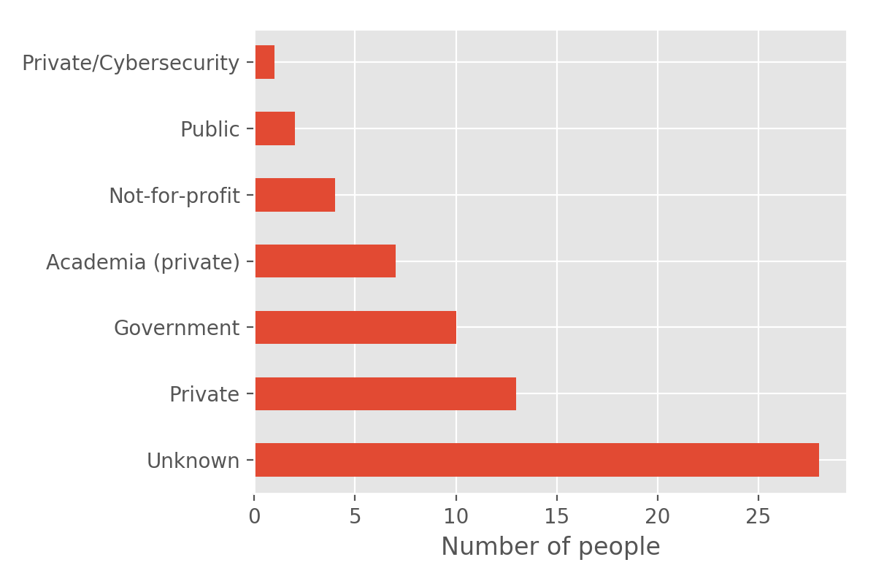

*Note: To protect confidentiality of the crowdlaw users, we will not reveal their names or the names of the organizations that they work for. The information we have presented here is intended to aid in an overall understanding of who currently uses crowdlaw and how crowdlaw can be made more accessible.*

Of those users whose employers we were able to identify, ___% work for private companies. These companies are a mix of startups and digital agencies that provide services in IT, GIS, data visualization, website optimization and management consulting. About ten users work in different levels of government. Academics and researchers — who come from a wide variety of disciplines including urban planning, higher education and environmental management — have also take keen interest in open data policy-making.

***Do users with technical backgrounds only speak about technical issues?***

The graph shows the two top most occupations of users for each city. Of the open data users that we identified, most of them have technical backgrounds in software development, statistics, data science, data journalism and more. Few users come from other backgrounds such as academia, community management etc.

Based on the analysis, if crowdlaw is more accessible to users from technical backgrounds, how does it affect the type of language and kind of issues that dominate the discussion on crowdlaw?

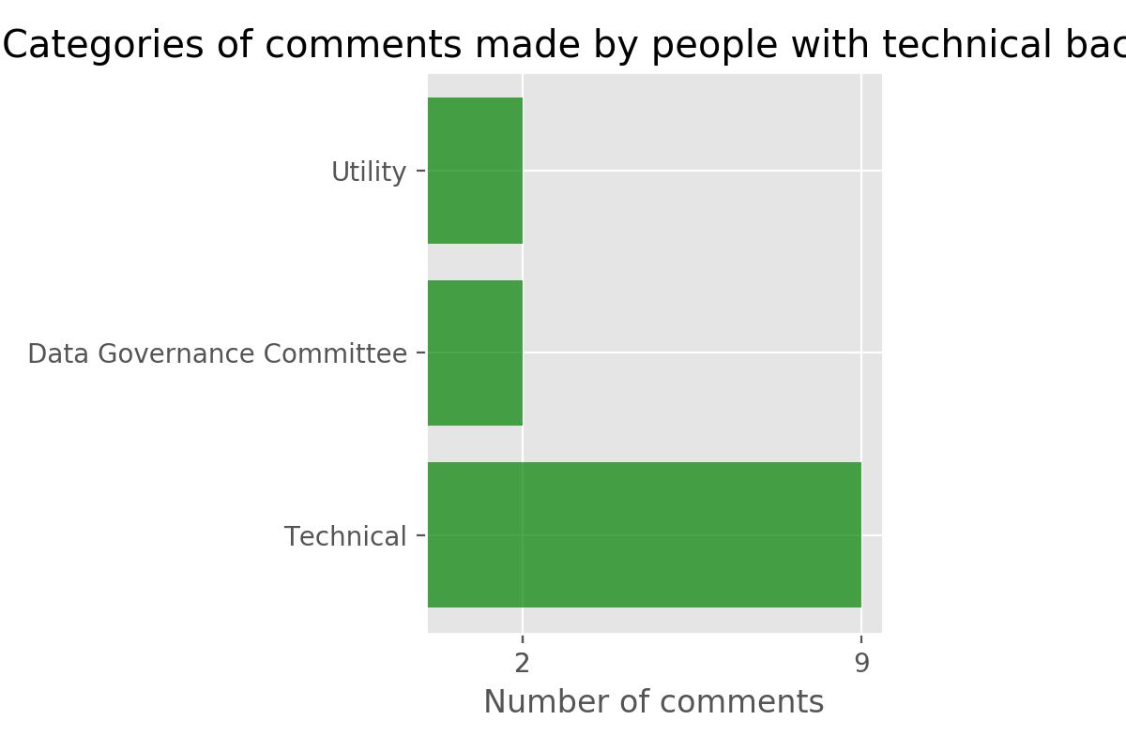

Most comments are technical in nature, referring to issues such as the need to adopt data standards, availability of metadata, APIs, and storing data in a central repository.

***How crowdlaw for open data could be made more accessible?***

A lot of discussion on crowdlaw is dominated by users on technical issues, in spite of the fact that there are users that come from non-technical backgrounds. If cities want to get feedback on draft open data policies from a more diverse range of users, they can do so by making it more accessible. As highlighted in [one](https://sunlightfoundation.com/2017/05/31/cities-need-your-help-making-better-open-data-policy/) of Sunlight’s blog posts, this can be done in several ways:

* By directly seeking participation through survey forms, as has been executed by the [City of Buffalo](https://sunlightfoundation.com/2017/03/23/how-opening-data-and-policy-to-the-public-online-can-make-both-better/) in the past.
* By using tools like [social media](https://docs.google.com/document/d/1bg7bvmjRbzlRYEoozABt0cEMGWjMXW506Gk-0tUtEKw/edit) to more effectively gather public participation.
* By disseminating information on the open data policy in town hall meetings.
* By looking at other best practices documented by Sunlight on [“Collecting Feedback”](http://whatworkscities.sunlightfoundation.com/#section-h2-06).

Our next blog post will examine whether the sentiment of comments on draft policies tends to be positive, neutral, or negative.